**Project Design Phase-II**

**Technology Stack (Architecture & Stack)**

|  |  |
| --- | --- |
| Date | 15 October 2022 |
| Team ID | PNT2022TMID48753 |
| Project Name | DemandEst-AI Powered Food Demand Forecaster |
| Maximum Marks | 4 Marks |

**Technical Architecture:**

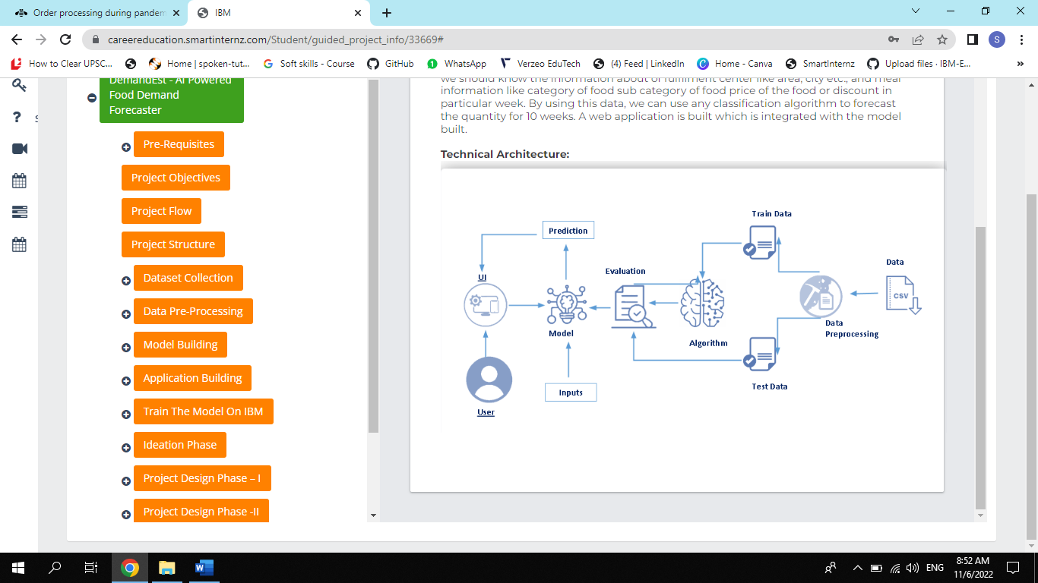

**Table-1 : Components & Technologies:**

|  |  |  |  |
| --- | --- | --- | --- |
| S.No | Component | Description | Technology |
|  | User Interface | The user interface (UI) is the point of human-computer interaction and communication in a device | HTML, CSS, JavaScript, React JS |
|  | Application Logic-1 | Google Collab is used for coding in the development of application. | Python |
|  | Application Logic-2 | To provide the train for the developed application using the dataset and to provide interaction between web app and the python codes. | IBM Watson STT service |
|  | Database | The database is used for storing the history of the client requirement and the services provided b the web app | MySQL |
|  | Cloud Database | Database Service on Cloud for accessing the database whenever it is needed. | IBM DB2 |
|  | File Storage | File storage requirements | IBM Block Storage or Local Filesystem |
|  | Machine Learning Model | Fueled by data, machine learning (ML) models are the mathematical engines of artificial intelligence. | Cross-sectional forecasting, Statistical analysis. |
|  | Infrastructure (Server / Cloud) | Application Deployment on Local System | Local |

**Table-2: Application Characteristics:**

| S.No | Characteristics | Description | Technology |
| --- | --- | --- | --- |
|  | Open-Source Frameworks | Open source software is different. Its authors make its source code available to others who would like to view that code, copy it, learn from it, alter it, or share it. | Anaconda, IBM |
|  | Security Implementations | Software security is the concept of implementing mechanisms in the construction of security to help it remain functional (or resistant) to attacks. | OWASP, Firewall |
|  | Scalable Architecture | Scalability is the property of a system to handle a growing amount of work by adding resources to the system. | Cloud based product like IBM Cloud |
|  | Availability | Demand forecasting allows businesses to optimize inventory by predicting future sales. By analysing historical sales data, demand managers can make informed business decisions | Statistical Analysis |
|  | Performance | Application performance indicates how the app is functioning and how responsive the app is to the end-user. | React JS |